**Air Mask Prototype Project Design**

Jinhan Yang

Seneca college

HSI355

December 7th 2023

**Introduction**

This is a project design based on course content, essentially a variable speed fan controlled by a Joystick and operated by a main switch. When the main switch is pressed, the entire project starts operating and lasts for 20 seconds. Only the Y-axis is involved in the adjustment. When the Y-axis is pulled upwards, the fan speed increases, and when pulled downwards, the speed decreases. The percentage speed is displayed on a digital display.

**Circuit**

**Input:** As shown in the diagram below, the used circuit features a PULL DOWN switch design. When the switch is pressed, the AIN0 reading drops to almost 0. The X-axis of the Joystick is ignored, as only the Y-axis is needed for adjustment in this design.

**Output:** The digital display uses the same connection as in lab4, employing DO0 to DO56 interfaces. When the Y-axis is pulled up, the number increases, and vice versa, reflecting the speed of the fan. The number 10 represents 100% speed, while 1 represents 10% speed. The second terminal is a motor; essentially, the fan is a motor, and its speed is regulated by different DAC output voltages. When the display shows 10, the output voltage is 5V, and the motor runs at full speed; otherwise, it slows down.

**Code**

Input: The overall code is in the attached C code file. The switch is a PULL Down design, and here's the switch part of the code:

Joystick adjustment involves only the Y-axis. Here's the Joystick part of the code:

Output: Since it's not necessary to repeatedly send numbers to display the percentage, under the ten percent display, here's the digital display part of the code:



Motor speed is entirely adjusted by different voltages. Here's the motor part of the code:



**Ideal Application Scenario**

As presented in the PPT, combined with a wearable facial tube and a fan body wrapped in a scarf with a bacterial filter membrane, this project aims to design a portable air mask. Since most air-borne diseases are caused by inhalation of liquid gels suspended in the air, this air mask uses sterile air impact to prevent the inhalation of liquid gels under the air curtain formed by the fan.

Compared to traditional masks, the air mask is portable, not stuffy, and no more uncomfortable. It doesn't need to hang on the ears, creates a sense of freshness through air flow, and also see the facilitates speaking and communication.

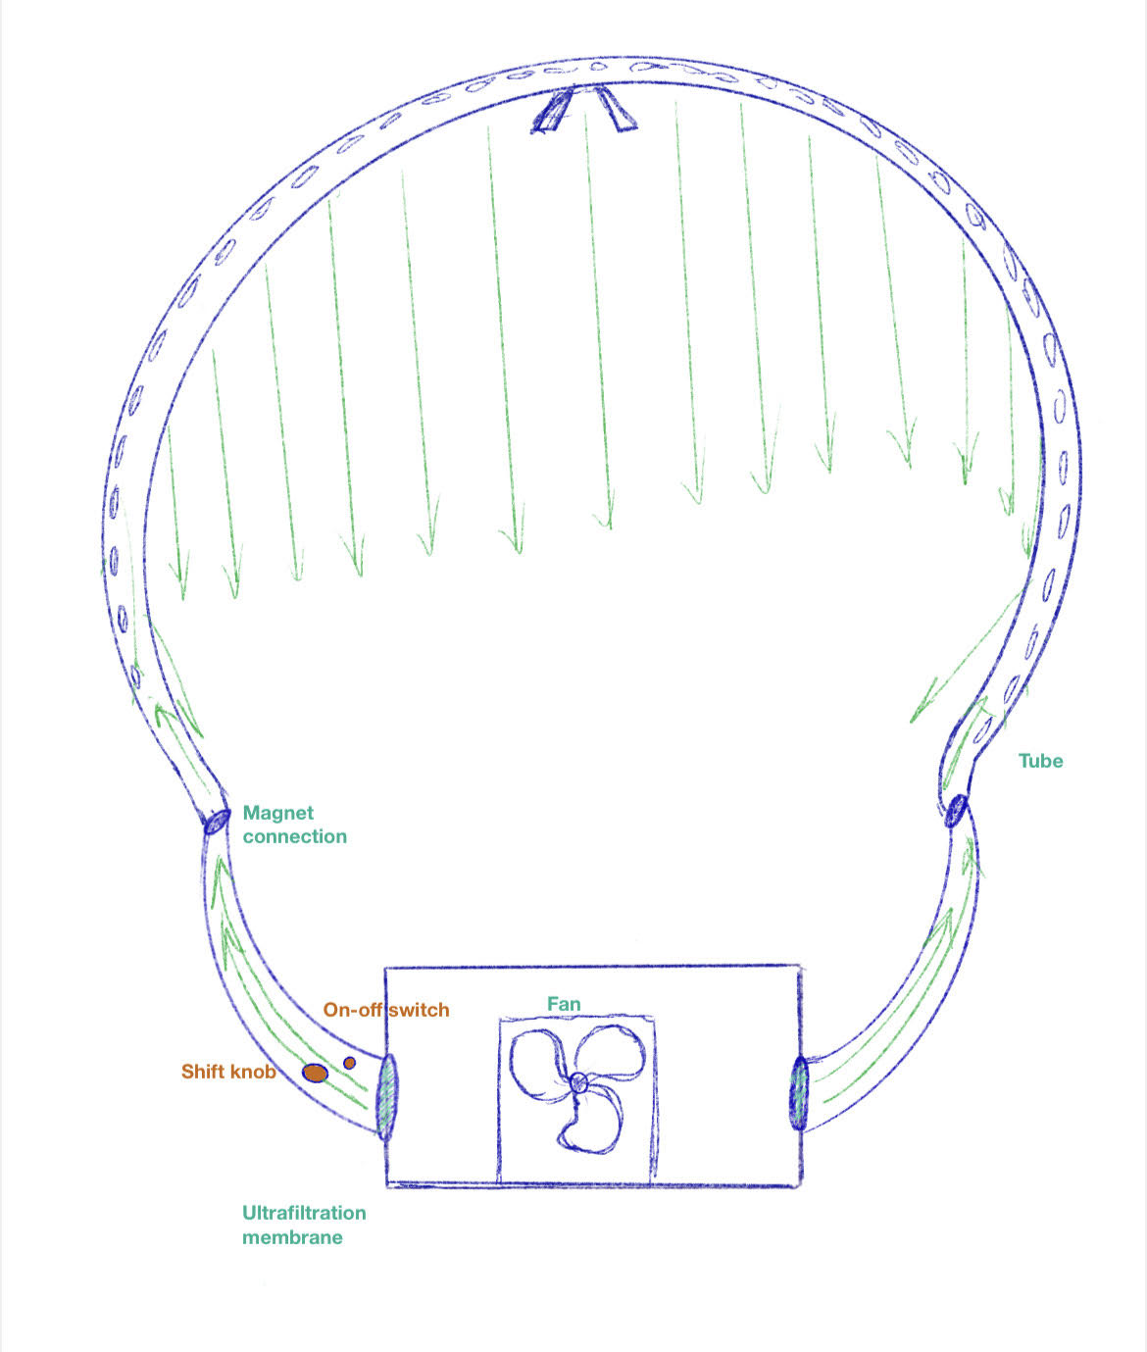

窗体顶端

窗体底端

